ASS -1(Solution)_Day_01 :

Roll Number : 1022_Chetan_Badgujar

Date : 24 / 05 / 2021

1. In your home directory, create sets of empty practice files

* Create 6 files with names of the forms on songsX.mp3.
* Create 6 files with names of the form snapX.jpg.
* Create 6 files with names of the form filmX.avi.

-------------------------------------------------------------------------------------------------

user1@localhost ~]$ cd Home

[user1@localhost Home]$ ls

filmx.avi fiLmX.avi snapX.jpg snaPx.jpj somgsX.mp3 songsX.mp3

filmX.avi FilmX.avi snapX.jpj Snapx.jpj songaX.mp3 SongsX.mp3

filMX.avi FIlmX.avi snapX.Jpj SnApx.jpj songsx.mp3 SongSx.mp3

[user1@localhost Home]$ clear

[user1@localhost Home]$ cd

[user1@localhost ~]$ ls

Desktop Documents Downloads Home Music Picture Public Templates Videos

[user1@localhost ~]$ pwd

/home/user1

[user1@localhost ~]$ cd Home

[user1@localhost Home]$ ls

filmx.avi fiLmX.avi snapX.jpg snaPx.jpj somgsX.mp3 songsX.mp3

filmX.avi FilmX.avi snapX.jpj Snapx.jpj songaX.mp3 SongsX.mp3

filMX.avi FIlmX.avi snapX.Jpj SnApx.jpj songsx.mp3 SongSx.mp3

[user1@localhost Home]$ ls -l

total 0

-rw-rw-r--. 1 user1 user1 0 May 16 23:37 filmx.avi

-rw-rw-r--. 1 user1 user1 0 May 16 23:37 filmX.avi

-rw-rw-r--. 1 user1 user1 0 May 16 23:38 filMX.avi

-rw-rw-r--. 1 user1 user1 0 May 16 23:38 fiLmX.avi

-rw-rw-r--. 1 user1 user1 0 May 16 23:39 FilmX.avi

-rw-rw-r--. 1 user1 user1 0 May 16 23:39 FIlmX.avi

-rw-rw-r--. 1 user1 user1 0 May 16 23:34 snapX.jpg

-rw-rw-r--. 1 user1 user1 0 May 16 23:35 snapX.jpj

-rw-rw-r--. 1 user1 user1 0 May 16 23:35 snapX.Jpj

-rw-rw-r--. 1 user1 user1 0 May 16 23:34 snaPx.jpj

-rw-rw-r--. 1 user1 user1 0 May 16 23:40 Snapx.jpj

-rw-rw-r--. 1 user1 user1 0 May 16 23:35 SnApx.jpj

-rw-rw-r--. 1 user1 user1 0 May 16 23:27 somgsX.mp3

-rw-rw-r--. 1 user1 user1 0 May 16 23:27 songaX.mp3

-rw-rw-r--. 1 user1 user1 0 May 16 23:29 songsx.mp3

-rw-rw-r--. 1 user1 user1 0 May 16 23:28 songsX.mp3

-rw-rw-r--. 1 user1 user1 0 May 16 23:31 SongsX.mp3

-rw-rw-r--. 1 user1 user1 0 May 16 23:31 SongSx.mp3

[user1@localhost Home]$

----------------------------------------------------------------------------------------------

­­­­­­­­­­­­­­­­­­­­­­

2. From your home directory,

* Move songs file into your Music subdirectory.

--------------------------------------------------------------------------------------------------------

[user1@localhost ~]$ cd

[user1@localhost ~]$ cd Music

[user1@localhost Music]$ ls

somgsX.mp3 songaX.mp3 songsx.mp3 SongsX.mp3 SongSx.mp3 SONGSX.mp3

[user1@localhost Music]$ ls -l

total 0

-rw-rw-r--. 1 user1 user1 0 May 16 23:27 somgsX.mp3

-rw-rw-r--. 1 user1 user1 0 May 16 23:27 songaX.mp3

-rw-rw-r--. 1 user1 user1 0 May 16 23:29 songsx.mp3

-rw-rw-r--. 1 user1 user1 0 May 16 23:31 SongsX.mp3

-rw-rw-r--. 1 user1 user1 0 May 16 23:31 SongSx.mp3

-rw-rw-r--. 1 user1 user1 0 May 17 00:21 SONGSX.mp3

[user1@localhost Music]$

---------------------------------------------------------------------------------------------------------

* Move snap file into your Pictures subdirectory.

[user1@localhost Music]$ cd

[user1@localhost ~]$ cd Picture

[user1@localhost Picture]$ ls

snapX.jpg snapX.jpj snapX.Jpj snaPx.jpj Snapx.jpj SnApx.jpj

[user1@localhost Picture]$ ls -l

total 0

-rw-rw-r--. 1 user1 user1 0 May 16 23:34 snapX.jpg

-rw-rw-r--. 1 user1 user1 0 May 16 23:35 snapX.jpj

-rw-rw-r--. 1 user1 user1 0 May 16 23:35 snapX.Jpj

-rw-rw-r--. 1 user1 user1 0 May 16 23:34 snaPx.jpj

-rw-rw-r--. 1 user1 user1 0 May 16 23:40 Snapx.jpj

-rw-rw-r--. 1 user1 user1 0 May 16 23:35 SnApx.jpj

[user1@localhost Picture]$

---------------------------------------------------------------------------------------------------------

* Move your movie files into Videos subdirectory

[user1@localhost ~]$ cd Videos

[user1@localhost Videos]$ ls

filmx.avi filmX.avi filMX.avi fiLmX.avi FilmX.avi FIlmX.avi Movies

[user1@localhost Videos]$ ls -l

total 0

-rw-rw-r--. 1 user1 user1 0 May 16 23:37 filmx.avi

-rw-rw-r--. 1 user1 user1 0 May 16 23:37 filmX.avi

-rw-rw-r--. 1 user1 user1 0 May 16 23:38 filMX.avi

-rw-rw-r--. 1 user1 user1 0 May 16 23:38 fiLmX.avi

-rw-rw-r--. 1 user1 user1 0 May 16 23:39 FilmX.avi

-rw-rw-r--. 1 user1 user1 0 May 16 23:39 FIlmX.avi

drwxrwxr-x. 2 user1 user1 6 May 13 05:09 Movies

[user1@localhost Videos]$

3. Create 3 subdirectories for organizing your files named friends,family,work

[user1@localhost ~]$ cd

[user1@localhost ~]$ pwd

/home/user1

[user1@localhost ~]$ ls -l

total 0

drwxr-xr-x. 2 user1 user1 6 May 12 22:46 Desktop

drwxr-xr-x. 2 user1 user1 33 May 13 04:46 Documents

drwxr-xr-x. 2 user1 user1 6 May 12 20:23 Downloads

drwxrwxr-x. 2 user1 user1 6 May 16 23:47 family

drwxrwxr-x. 2 user1 user1 6 May 16 23:47 friends

drwxrwxr-x. 2 user1 user1 6 May 17 00:30 Home

drwxr-xr-x. 2 user1 user1 114 May 17 00:21 Music

drwxr-xr-x. 2 user1 user1 108 May 17 00:28 Picture

drwxr-xr-x. 2 user1 user1 6 May 12 20:23 Public

drwxr-xr-x. 2 user1 user1 6 May 12 20:23 Templates

drwxr-xr-x. 3 user1 user1 122 May 17 00:30 Videos

drwxrwxr-x. 2 user1 user1 6 May 16 23:47 work

[user1@localhost ~]$

________________________________________________________________-

4. Copy files (all types ) containing numbers 1 and 2 to the friends folder

-----------------------------------------------------------------------------------------------

[user1@localhost ~]$ cd

[user1@localhost ~]$ ls -l

total 0

drwxrwxr-x. 2 user1 user1 6 May 17 04:23 Chetan

drwxr-xr-x. 2 user1 user1 6 May 12 22:46 Desktop

drwxr-xr-x. 2 user1 user1 33 May 13 04:46 Documents

drwxr-xr-x. 2 user1 user1 6 May 12 20:23 Downloads

drwxrwxr-x. 2 user1 user1 110 May 17 04:07 family

drwxrwxr-x. 2 user1 user1 110 May 17 04:22 friends

drwxrwxr-x. 2 user1 user1 6 May 17 00:30 Home

drwxr-xr-x. 2 user1 user1 114 May 17 00:21 Music

drwxr-xr-x. 2 user1 user1 108 May 17 00:28 Picture

drwxr-xr-x. 2 user1 user1 6 May 12 20:23 Public

drwxr-xr-x. 2 user1 user1 6 May 12 20:23 Templates

drwxr-xr-x. 3 user1 user1 122 May 17 00:30 Videos

drwxrwxr-x. 2 user1 user1 110 May 17 04:18 work

[user1@localhost ~]$ cd friends

[user1@localhost friends]$ ls -l

total 0

-rw-rw-r--. 1 user1 user1 0 May 17 03:55 filmx.avi

-rw-rw-r--. 1 user1 user1 0 May 17 03:55 filmX.avi

-rw-rw-r--. 1 user1 user1 0 May 17 03:50 snapX.jpg

-rw-rw-r--. 1 user1 user1 0 May 17 03:51 snapX.jpj

-rw-rw-r--. 1 user1 user1 0 May 17 03:46 somgsX.mp3

-rw-rw-r--. 1 user1 user1 0 May 17 03:48 songaX.mp3

[user1@localhost friends]$

=-----------------------------------------------------------------------------------.

* Copy files (all types) containing numbers 3 and 4 to the family folder.

[user1@localhost family]$ cd

[user1@localhost ~]$ ls -l

total 0

drwxrwxr-x. 2 user1 user1 6 May 17 04:23 Chetan

drwxr-xr-x. 2 user1 user1 6 May 12 22:46 Desktop

drwxr-xr-x. 2 user1 user1 33 May 13 04:46 Documents

drwxr-xr-x. 2 user1 user1 6 May 12 20:23 Downloads

drwxrwxr-x. 2 user1 user1 110 May 17 04:07 family

drwxrwxr-x. 2 user1 user1 110 May 17 04:22 friends

drwxrwxr-x. 2 user1 user1 6 May 17 00:30 Home

drwxr-xr-x. 2 user1 user1 114 May 17 00:21 Music

drwxr-xr-x. 2 user1 user1 108 May 17 00:28 Picture

drwxr-xr-x. 2 user1 user1 6 May 12 20:23 Public

drwxr-xr-x. 2 user1 user1 6 May 12 20:23 Templates

drwxr-xr-x. 3 user1 user1 122 May 17 00:30 Videos

drwxrwxr-x. 2 user1 user1 110 May 17 04:18 work

[user1@localhost ~]$ cd family

[user1@localhost family]$ ls -l

total 0

-rw-rw-r--. 1 user1 user1 0 May 17 04:05 filMX.avi

-rw-rw-r--. 1 user1 user1 0 May 17 04:05 fiLmX.avi

-rw-rw-r--. 1 user1 user1 0 May 17 04:07 snapX.Jpj

-rw-rw-r--. 1 user1 user1 0 May 17 04:07 snaPx.jpj

-rw-rw-r--. 1 user1 user1 0 May 17 04:03 songsx.mp3

-rw-rw-r--. 1 user1 user1 0 May 17 04:04 SongsX.mp3

[user1@localhost family]$

* Copy files (all types) containing numbers 5 and 6 to the work folder.

# **[user1@localhost family]$ cd**

# **[user1@localhost ~]$ cd work**

# **[user1@localhost work]$ ls -l**

# **total 0**

# **-rw-rw-r--. 1 user1 user1 0 May 17 04:14 FilmX.avi**

# **-rw-rw-r--. 1 user1 user1 0 May 17 04:14 FIlmX.avi**

# **-rw-rw-r--. 1 user1 user1 0 May 17 04:17 Snapx.jpj**

# **-rw-rw-r--. 1 user1 user1 0 May 17 04:18 SnApx.jpj**

# **-rw-rw-r--. 1 user1 user1 0 May 17 04:10 SongSx.mp3**

# **-rw-rw-r--. 1 user1 user1 0 May 17 04:12 SONGSX.mp3**

# **[user1@localhost work]$**

5. Delete all files in family subdirectory.

----------------------------------------------------------------------------------------------------

[user1@localhost family]$ ls -l

total 0

-rw-rw-r--. 1 user1 user1 0 May 17 04:05 filMX.avi

-rw-rw-r--. 1 user1 user1 0 May 17 04:05 fiLmX.avi

-rw-rw-r--. 1 user1 user1 0 May 17 04:07 snapX.Jpj

-rw-rw-r--. 1 user1 user1 0 May 17 04:07 snaPx.jpj

-rw-rw-r--. 1 user1 user1 0 May 17 04:03 songsx.mp3

-rw-rw-r--. 1 user1 user1 0 May 17 04:04 SongsX.mp3

[user1@localhost family]$ rm -r filMX.avi

[user1@localhost family]$ rm -r fiLmX.avi

[user1@localhost family]$ rm -r snapX,Jpj

rm: cannot remove ‘snapX,Jpj’: No such file or directory

[user1@localhost family]$ rm -r snaPx.jpj

[user1@localhost family]$ rm -r songsx.mp3

[user1@localhost family]$ rm -r SongsX.mp3

[user1@localhost family]$ ls -l

total 0

-rw-rw-r--. 1 user1 user1 0 May 17 04:07 snapX.Jpj

[user1@localhost family]$

6. Delete friends subdirectory

-------------------------------------------------------------------------------------------------

[user1@localhost friends]$ cd

[user1@localhost ~]$ ls -l

total 0

drwxrwxr-x. 2 user1 user1 6 May 17 04:23 Chetan

drwxr-xr-x. 2 user1 user1 6 May 12 22:46 Desktop

drwxr-xr-x. 2 user1 user1 33 May 13 04:46 Documents

drwxr-xr-x. 2 user1 user1 6 May 12 20:23 Downloads

drwxrwxr-x. 2 user1 user1 23 May 17 04:33 family

drwxrwxr-x. 2 user1 user1 110 May 17 04:22 friends

drwxrwxr-x. 2 user1 user1 6 May 17 00:30 Home

drwxr-xr-x. 2 user1 user1 114 May 17 00:21 Music

drwxr-xr-x. 2 user1 user1 108 May 17 00:28 Picture

drwxr-xr-x. 2 user1 user1 6 May 12 20:23 Public

drwxr-xr-x. 2 user1 user1 6 May 12 20:23 Templates

drwxr-xr-x. 3 user1 user1 122 May 17 00:30 Videos

drwxrwxr-x. 2 user1 user1 110 May 17 04:18 work

[user1@localhost ~]$ cd friends

[user1@localhost friends]$ ls -l

total 0

-rw-rw-r--. 1 user1 user1 0 May 17 03:55 filmx.avi

-rw-rw-r--. 1 user1 user1 0 May 17 03:55 filmX.avi

-rw-rw-r--. 1 user1 user1 0 May 17 03:50 snapX.jpg

-rw-rw-r--. 1 user1 user1 0 May 17 03:51 snapX.jpj

-rw-rw-r--. 1 user1 user1 0 May 17 03:46 somgsX.mp3

-rw-rw-r--. 1 user1 user1 0 May 17 03:48 songaX.mp3

[user1@localhost friends]$ rm filmx.avi

[user1@localhost friends]$ rm filmX.avi

[user1@localhost friends]$ rm snapX.jpg

[user1@localhost friends]$ rm -r somgsX.mp3

[user1@localhost friends]$ rm -r songaX.mp3

[user1@localhost friends]$ ls -l

total 0

-rw-rw-r--. 1 user1 user1 0 May 17 03:51 snapX.jpj

[user1@localhost friends]$

----------------------------------------------------------------------------------------------------

7. rename all snap files in work directory to new name photoX.jpg

X is a number

[user1@localhost ~]$ cd

[user1@localhost ~]$ cd work

[user1@localhost work]$ ls -l

total 0

-rw-rw-r--. 1 user1 user1 0 May 17 04:14 FilmX.avi

-rw-rw-r--. 1 user1 user1 0 May 17 04:14 FIlmX.avi

-rw-rw-r--. 1 user1 user1 0 May 17 04:17 Snapx.jpj

-rw-rw-r--. 1 user1 user1 0 May 17 04:18 SnApx.jpj

-rw-rw-r--. 1 user1 user1 0 May 17 04:10 SongSx.mp3

-rw-rw-r--. 1 user1 user1 0 May 17 04:12 SONGSX.mp3

[user1@localhost work]$ mv FilmX.avi PhotoX,jpj

[user1@localhost work]$ mv FIlmX.avi PhotoX.jpj

[user1@localhost work]$ mv Snapx.jpj photoX.jpj

[user1@localhost work]$ mv SnApx.jpj photox.Jpj

[user1@localhost work]$ mv SongSx.mp3 PhoTox.jpj

[user1@localhost work]$ mv SONGSX.MP3 photoX.mp3

mv: cannot stat ‘SONGSX.MP3’: No such file or directory

[user1@localhost work]$ mv SONGSX.mp3 photo6.mp3

[user1@localhost work]$ ls -l

total 0

-rw-rw-r--. 1 user1 user1 0 May 17 04:12 photo6.mp3

-rw-rw-r--. 1 user1 user1 0 May 17 04:18 photox.Jpj

-rw-rw-r--. 1 user1 user1 0 May 17 04:17 photoX.jpj

-rw-rw-r--. 1 user1 user1 0 May 17 04:14 PhotoX,jpj

-rw-rw-r--. 1 user1 user1 0 May 17 04:14 PhotoX.jpj

-rw-rw-r--. 1 user1 user1 0 May 17 04:10 PhoTox.jpj

ASS -2(Solution)_Day_02 :

Roll Number : 1022_Chetan_Badgujar

ASS-2 :Solution -:

1. Create user tom , bob , sam , prince

🡺

[root@localhost ~]# tail -n 5 /etc/passwd

Demo:x:1001:1001::/home/Demo:/bin/bash

tom:x:1002:1002::/home/tom:/bin/bash

bob:x:1003:1003::/home/bob:/bin/bash

sam:x:1004:1004::/home/sam:/bin/bash

prince:x:1005:1005::/home/prince:/bin/bash

[root@localhost ~]#

2. Create Group dac , dbda ,ditiss

🡺[user1@localhost ~]$ cd

[user1@localhost ~]$ pwd

/home/user1

[user1@localhost ~]$ tail /etc/group

postfix:x:89:

ntp:x:38:

stapusr:x:156:

stapsys:x:157:

stapdev:x:158:

tcpdump:x:72:

user1:x:1000:user1

dac:x:1001:

dbdb:x:1002:

ditiss:x:1003:

[user1@localhost ~]$

3. add user

Tom in dac

Bob in dbda

Sam in ditiss

4. login as prince and create iacsd directory in /tmp and create 4 files in iacsd with name project-1 project-2 upto 4

🡺

5. assign permissions to project files as below

Project-1 – tom should be owner of this

Project-2 – dac should be owner of this

Project-3 --- others should not have any permission but tom should have rw access

Project-4 – dbda group should have rwx permissions.

🡺

ASS -3(Solution)_Day_03 :

Roll Number : 1022_Chetan_Badgujar

Date : 24 / 05 / 2021

1.Calculate the average waiting time.

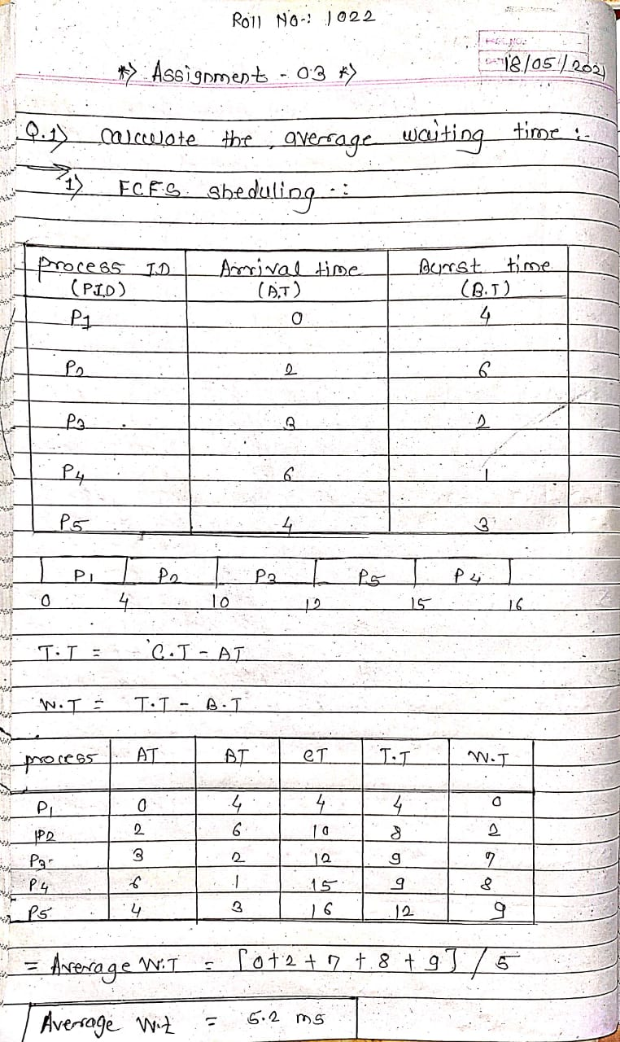

**SJF non-preemptive**

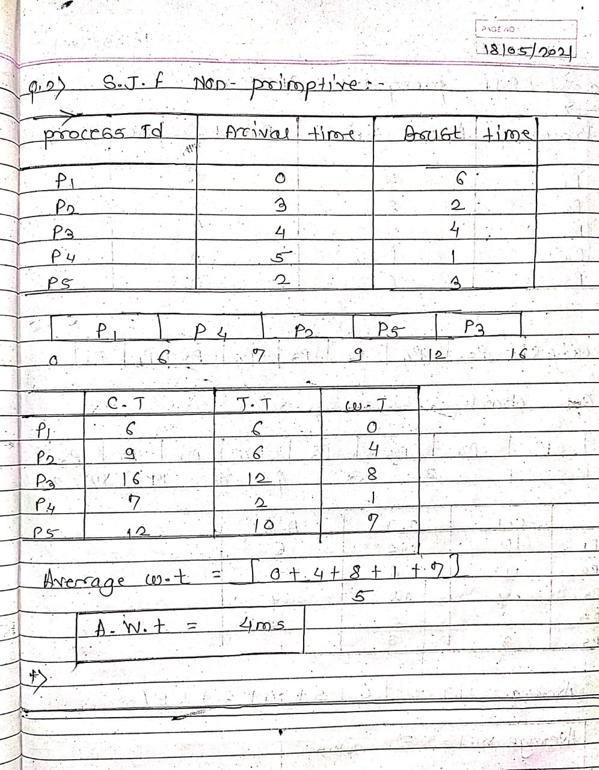

**SJF preemptive -SRTF**

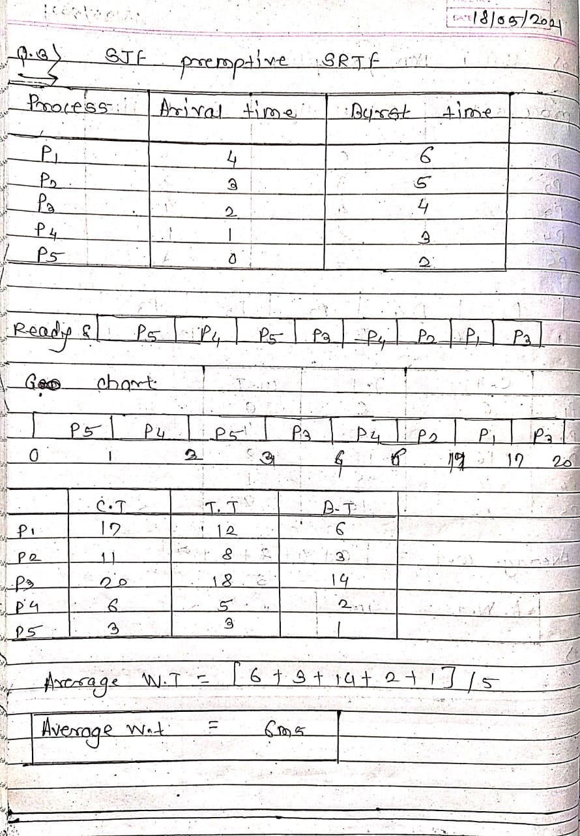

## Round Robin

Q=3

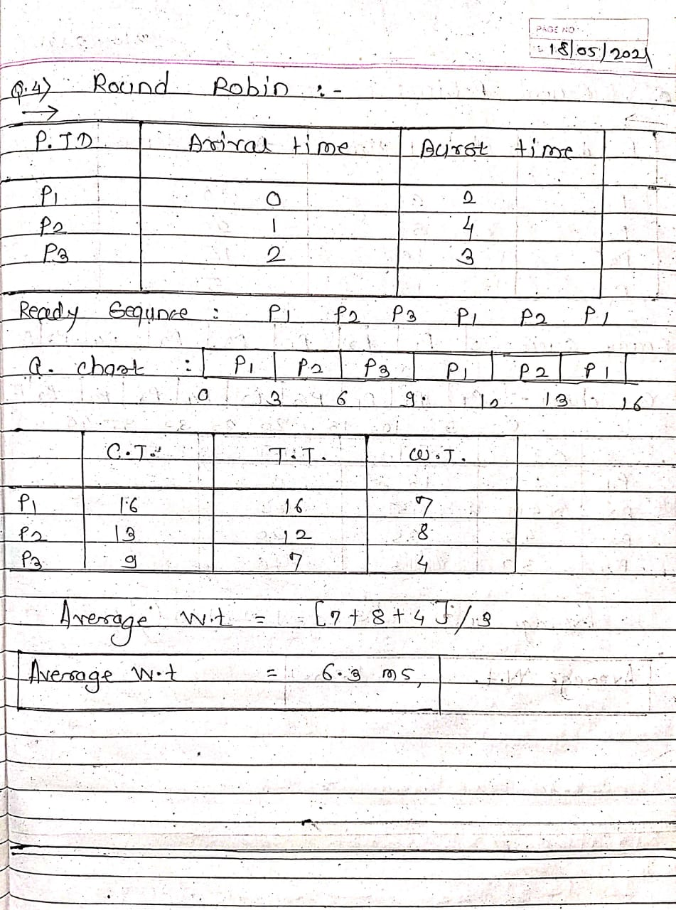

## Round Robin

Q=5

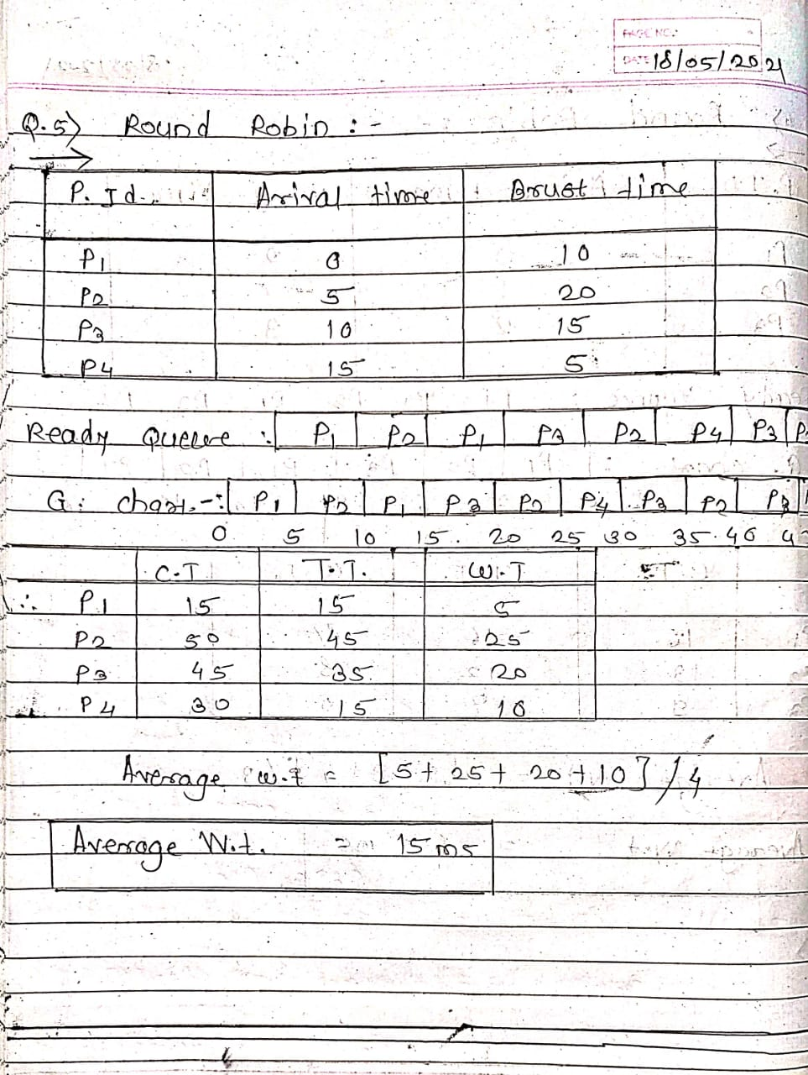

ASS -4(Solution)_Day_04 :

Roll Number : 1022_Chetan_Badgujar

Date : 24 / 05 / 2021

1. Write a shell script to calculate simple interest.

🡺

-------------------------------------------------------------------------------------------------------

#!/bin/bash

read -p "Enter the principle Amound ;" P

read -p "Enter the number of year ;" N

read -p 'Enter the rate of interest calculate anually :" R

si=`expr $P \* $N \* $R / 100`

echo "Interest after $N year : " $si

A=`echo "$P+$N" | bc`

echo "Total amount is == $A"

OUTPUT :

2) Write a shell script to calculate salary from given basic.

Salary = basic + dp + da +hra +ma –pf

basic – to be taken as input

dp - 50 % of basic

da - 35 % of (basic + dp)

hra - 8 % of (basic + dp)

ma - 3 % of (basic + dp)

pf - 10% of (basic + dp)

🡺

-------------------------------------------------------------------------------------------------------------------

GNU nano 2.3.1 File: bs.sh

#!/bin/bash

read -p "Enter your basic salary ==> " basic

dp=`echo "0.50*$basic" | bc`

da=`echo "0.35*($basic+$dp)" | bc`

hra=`echo "0.08*($basic+$dp)" | bc`

ma=`echo "0.03*($basic+$dp)" | bc`

pf=`echo "0.10*($basic+$dp)" | bc`

salary=`echo "$basic + $dp + $da + $hra + $ma - $pf" | bc`

echo "Gross Salary=$salary"

--------------------------------------------------------------------------------------------------------------

TERMINAL/OUTPUT :

[user1@localhost ~]$ nano bs.sh

[user1@localhost ~]$ ./bs.sh

Enter your basic salary ==> 25000

Gross Salary=51000.00

[user1@localhost ~]$ ./bs.sh

Enter your basic salary ==> 12000

Gross Salary=24480.00

[user1@localhost ~]$

1. Write a shell script to calculate the average of a 3 number.

🡺

------------------------------------------------------------------------------------------------

GNU nano 2.3.1 File: average.c

read -p echo "Enter the one number :" num1

read -p echo "Enter the second Number : " num2

read -p echo "Enter the Third Number : " num3

echo "Calculating Average Of Thre Number : "

average=`echo "($num1+$num2+$num3)/3"

echo "Averaagr of three NUmber : " $average

------------------------------------------------------------------------------------------------------------------------

OUTPUT :

[user1@localhost ~]$ nano Avr.sh

[user1@localhost ~]$

[user1@localhost ~]$

[user1@localhost ~]$ chmod +x Avr.sh

[user1@localhost ~]$ ./Avr.sh

Enter the first number :45

Enter the second numner : 85

Enter the third numbet : 95

Average of third number : 60

[user1@localhost ~]$

4). Write a shell script to create a command line calculator.

e.g. input : mycal 5 + 5 Result : 10 , input : mycal 5 / 5 result : 1

🡺

-----------------------------------------------------------------------------------------------------------------------

GNU nano 2.3.1 File: case.sh

read -p "Enter the first number : " num1

read -p "Enter the seconfd number : " num2

echo "Enter the oepration you want to performed : "

echo "Type + for Addition - for Subtraction * for Multipication / division "

read -p "Enter the choice " choice

case $choice in

+) sum=`echo "$num1 + $num2" | bc`

echo "Addition is ==> $sum"

;;

-) sub=`echo "$num1 - $num2" | bc`

echo "SUbtraction is ==> $sub"

;;

*) mul=`echo "$num1 * $num2" | bc`

echo "multipication is ==> $mul"

;;

OUTPUT :

[user1@localhost ~]$ nano case.sh

[user1@localhost ~]$ chmod +x case.sh

[user1@localhost ~]$ ./case.sh

Enter the first number : 200

Enter the seconfd number : 100

Enter the oepration you want to performed :

Type + for Addition - for Subtraction * for Multipication / division

Enter the choice +

Addition is ==> 300

[user1@localhost ~]$ ./case.sh

Enter the first number : 400

Enter the seconfd number : 200

Enter the oepration you want to performed :

Type + for Addition - for Subtraction * for Multipication / division

Enter the choice -

SUbtraction is ==> 200

[user1@localhost ~]$ ./case.sh

Enter the first number : 100

Enter the seconfd number : 500

Enter the oepration you want to performed :

Type + for Addition - for Subtraction * for Multipication / division

Enter the choice *

multipication is ==> 50000

[user1@localhost ~]$ 100

bash: 100: command not found...

[user1@localhost ~]$ ./case.sh

Enter the first number : 10000

Enter the seconfd number : 500

Enter the oepration you want to performed :

Type + for Addition - for Subtraction * for Multipication / division

Enter the choice

-------------------------------------------------------------------------------------------------------

5) Write a shell script to accept 2 numbers and display which number is greater

🡺

-------------------------------------------------------------------------------------------------------------------

GNU nano 2.3.1 File: twonum.sh

read -p "Enter the one number :" num1

read -p " Enter the second number :" num2

if [ $num1 -gt $num2 ]

then

echo $num1 " is greter then " $num2

else

echo $num2 " is greter "

fi

OUTPUT :

[user1@localhost ~]$ nano twonum.sh

[user1@localhost ~]$ chmod +x twonum.sh

[user1@localhost ~]$ ./twonum.sh

Enter the one number :145

Enter the second number :144

145 is greter then 144

[user1@localhost ~]$

6) Create a script to

Creat user , Delete User , Create Group ,Delete Group using case:

--------------------------------------------------------------------------------------------------

🡺 GNU nano 2.3.1 File: grp.sh

echo "GIven Menu : 1. creat User 2. Delet user 3.Creat group 4. Delet group"

echo "Enter your choice :"

read -p "CHOICE :" C

case $C in

1) echo "Creating user :"

read -p "Enter the username" username

sudo useradd $username

;;

2)echo "Deleting User "

read -p "Enter username :" Dusername

sudo deluser $Dusername

;;

3)echo "Creating Group :"

read -p "Enter the group name : " grpname

sudo groupadd $grpname

--------------------------------------------------------------------------------------------------------------

OUTPUT 🡺[user1@localhost ~]$ nano grp.sh

[user1@localhost ~]$ chmod +x grp.sh

[user1@localhost ~]$ ./grp.sh

GIven Menu : 1. creat User 2. Delet user 3.Creat group 4. Delet group

Enter your choice :

CHOICE :1

Creating user :

Enter the usernameDeva

[sudo] password for user1:

user1 is not in the sudoers file. This incident will be reported.

[user1@localhost ~]$ ./grp.sh

GIven Menu : 1. creat User 2. Delet user 3.Creat group 4. Delet group

Enter your choice :

CHOICE :2

Deleting User

Enter username :sampleuser

[sudo] password for user1:

Sorry, try again.

[sudo] password for user1:

user1 is not in the sudoers file. This incident will be reported.

[user1@localhost ~]$ clear

[user1@localhost ~]$ nano grp.sh

[user1@localhost ~]$ ./grp.sh

GIven Menu : 1. creat User 2. Delet user 3.Creat group 4. Delet group

Enter your choice :

CHOICE :1

Creating user :

Enter the username DemoUser1

[sudo] password for user1:

user1 is not in the sudoers file. This incident will be reported.

[user1@localhost ~]$ ./grp.sh

GIven Menu : 1. creat User 2. Delet user 3.Creat group 4. Delet group

Enter your choice :

CHOICE :3

Creating Group :

Enter the group name : demogroup1

[sudo] password for user1:

user1 is not in the sudoers file. This incident will be reported.

[user1@localhost ~]$ ./grp.sh

GIven Menu : 1. creat User 2. Delet user 3.Creat group 4. Delet group

Enter your choice :

CHOICE :4

Deleting Group ;

Enter the grouo name :dgrpname demogroup1

[sudo] password for user1:

user1 is not in the sudoers file. This incident will be reported.

[user1@localhost ~]$

ASS -5(Solution)_Day_05 :

Roll Number : 1022_Chetan_Badgujar

Date : 24 / 05 / 2021

1. Write a script to find out String is palindrome or not.

-------------------------------------------------------------------------------------------------

#!/bin/bash

read -p "Enter the Number :" n1

num=$n1

R=0

while [ $num -gt 0 ]

do

r=`echo "$num%10" | bc`

R=`echo "($R*10)+$r" | bc`

num=`echo "($num / 10)" | bc`

done

if [ $R -eq $n1 ]

then

echo "Given number is palindrom :"

else

echo "not palindrom :"

fi

OUTPUT :

[user1@localhost ~]$ nano pelindrom.sh

[user1@localhost ~]$ chmod +x pelindrom.sh

[user1@localhost ~]$ ./pelindrom.sh

Enter the Number :15951

Given number is palindrom :

[user1@localhost ~]$ ./pelindrom.sh

Enter the Number :1411

not palindrom :

[user1@localhost ~]$ ./pelindrom.sh

Enter the Number :121

Given number is palindrom :

[user1@localhost ~]$

1. Write a shell script to accept 10 numbers and tell how many are +tive, -tive and zero.

----------------------------------------------------------------------------------------------------------

GNU nano 2.3.1 File: p.sh

#!/bin/bash

a=0

b=0

c=0

for(( i=0; $i<=10; i++ ))

do

read -p "Enter the numer : " num1

if [ $num1 -gt 0 ]

then

b=$((b+1))

elif [ $num1 -gt 0 ]

then

a=$((b+1))

elif [ $num1 -lt 0 ]

then

a=$((a+1))

else

c=$((c+1))

OUTPUT :

[user1@localhost ~]$ nano p.sh

[user1@localhost ~]$ chmod +x p.sh

[user1@localhost ~]$ ./p.sh

Enter the numer : 100

Enter the numer : 200

Enter the numer : 300

Enter the numer : -400

Enter the numer : 0

Enter the numer : -500

Enter the numer : 0

Enter the numer : 0

Enter the numer : 120

Enter the numer : 51

Enter the numer : 741

Positive Number Are ==> 6

Negative NUmber Are ==> 2

Zeros Numbers Are ==> 3

[user1@localhost ~]$

1. Write a shell script to print given number’s sum of all digits (eg. If number is 123, then it’s sum of all digits will be 1+2+3=6)

🡺

-----------------------------------------------------------------------------------------------------------

GNU nano 2.3.1 File: add.sh

#!/bin/bash

echo "Programme for Addition of three numbers :"

read -p "Enter the number :" num1

a=`echo "$num1%10" | bc`

echo "$a"

b=`echo "$num1/10" | bc`

c=`echo "$b%10" | bc`

echo "$c"

d=`echo "$b/10" | bc`

echo "$d"

sum=`echo "$a+$c+$d" | bc`

echo "sum of the numbers is = $

OUTPUT:

user1@localhost ~]$ nano add.sh

[user1@localhost ~]$ chmod +x add.sh

[user1@localhost ~]$ ./add.sh

Programme for Addition of three numbers :

Enter the number :789

9

8

7

sum of the numbers is = 24

[user1@localhost ~]$ ./add.sh

Programme for Addition of three numbers :

Enter the number :123

3

2

1

sum of the numbers is = 6

[user1@localhost ~]$ ./add.sh

Programme for Addition of three numbers :

Enter the number :789

9

8

7

sum of the numbers is = 24

[user1@localhost ~]

4)Write a shell script to display the prime numbers from 1 to n ( n is a given number )

🡺----------------------------------------------------------------------------------------------------------------

GNU nano 2.3.1 File: prime.sh

#!/bin/bash

read -p "Enter the value of N for prime :" n

echo "n=$n"

echo "The Prime NUmber Between 1 and $n :"

for ((i=2; i<=$n; i++))

do

a=0

for ((j=2; j<i; j++))

do

b=`expr $i % $j`

if [ $b -eq 0 ]

then

a=1

fi

done

if [ $a -eq 0 ]

then

OUTPUT :

[user1@localhost ~]$ nano prime.sh

[user1@localhost ~]$ chmod +x prime.sh

[user1@localhost ~]$ ./prime.sh

Enter the value of N for prime :25

n=25

The Prime NUmber Between 1 and 25 :

2

3

5

7

11

13

17

19

23

[user1@localhost ~]$

1. Write a shell script to find whether a given year is leap year or not

🡺

----------------------------------------------------------------------------------------------

GNU nano 2.3.1 File: leap.sh

#!/bin/bash

echo "Find the Leap Year or Not ----------- "

T=0

YEAR=0

while [ $YEAR -le 0 ]

do

read -p "ENTER THE YEAR FROM USER ==> " YEAR

done

A=`echo "$YEAR%4" | bc`

T=$A

if [ $A -eq 0 ]

then

echo "Enter the YEAR - $YEAR is aleap Year :"

else

echo "Enter the YEAR - $YEAR is Not a Leap year :"

fi

OUTPUT :

[user1@localhost ~]$ nano leap.sh

[user1@localhost ~]$ chmod +x leap.sh

[user1@localhost ~]$ ./leap.sh

Find the Leap Year or Not -----------

ENTER THE YEAR FROM USER ==> 2024

Enter the YEAR - 2024 is aleap Year :

[user1@localhost ~]$ ./leap.sh

Find the Leap Year or Not -----------

ENTER THE YEAR FROM USER ==> 2020

Enter the YEAR - 2020 is aleap Year :

[user1@localhost ~]$ ./leap.sh

Find the Leap Year or Not -----------

ENTER THE YEAR FROM USER ==> 2021

Enter the YEAR - 2021 is Not a Leap year :

[user1@localhost ~]$

ASS -6(Solution)_Day_06 :

Roll Number : 1022_Chetan_Badgujar

Date : 24 / 05 / 2021

----------------------------------------------------------------------------------------------------------------

1.Write a shell script to create a menu driven program for adding, deletion or finding a record in a database. Database should have the field like rollno, name, semester and marks of three subjects. Last option of the menu should be to exit the menu.

🡺 GNU nano 2.3.1 File: menu.sh

#!/bin/bash

i=0

while [ $i == 0 ]

do

echo "Enter the choice to performed following operations :"

echo "1) Adding :"

echo "2) Deleting :"

echo "3) Finding :"

echo "4) Exit :"

read -p "Enter your choice " choice

case "$choice" in

1)read -p "Enter the roll number :" roll

read -p "Enter the name :" name

read -p "Enter the semister: "sem

read -p "Enter the marks pf 3 subjects out of 300 " marks

--------------------------------------------------------------------------------------------------------------

Output /Terminal :

Enter the choice to performed following operations :

1) Adding :

2) Deleting :

3) Finding :

4) Exit :

Enter your choice 2

Deleting your record by roll number :3

sed: no input files

Enter the choice to performed following operations :

1) Adding :

2) Deleting :

3) Finding :

4) Exit :

Enter your choice clear

Enter the choice to performed following operations :

1) Adding :

2) Deleting :

3) Finding :

4) Exit :

Enter your choice 4

invalid Choice

[user1@localhost ~]$ clear

[user1@localhost ~]$ nano menu.sh

[user1@localhost ~]$ chmod +x menu.sh

[user1@localhost ~]$ ./menu.sh

Enter the choice to performed following operations :

1) Adding :

2) Deleting :

3) Finding :

4) Exit :

Enter your choice 1

Enter the roll number :1

Enter the name :SAM

Enter the semister: sem 2

Enter the marks pf 3 subjects out of 300 250

Enter the choice to performed following operations :

1) Adding :

2) Deleting :

3) Finding :

4) Exit :

Enter your choice 1

Enter the roll number :2

Enter the name :BOB

Enter the semister: sem03

Enter the marks pf 3 subjects out of 300 222

Enter the choice to performed following operations :

1) Adding :

2) Deleting :

3) Finding :

4) Exit :

Enter your choice 2

Deleting your record by roll number :2

sed: no input files

Enter the choice to performed following operations :

1) Adding :

2) Deleting :

3) Finding :

4) Exit :

Enter your choice 3

Find the record ==> 222

./menu.sh: line 25: read: `-h': not a valid identifier

Enter the choice to performed following operations :

1) Adding :

2) Deleting :

3) Finding :

4) Exit :

Enter your choice 4

invalid Choice

[user1@localhost ~]$ cat record

name=che roll number ==>10 semister = mark=255

name=chetan roll number ==>1022 semister = mark=240

name=chetan roll number ==>2 semister = mark=255

name=SAM roll number ==>1 semister = mark=250

name=BOB roll number ==>2 semister = mark=222

[user1@localhost ~]$

2.Write a unix shell to add records to a file called item.dat The fields being itemcode, qty, sold and rate

item_code to be generated

qty_sold should be greater than 0

1. rate between 100 to 10000
2. 🡺---------------------------------------------------------------------------------------------------------------
3. GNU nano 2.3.1 File: unix.sh
4. #!/bin/bash
5. read -p "Enter a item code ==> " code
6. read -p "Enter the Quality ==> " Qty
7. read -p "Enter Rate ==> " rate
8. #if (($rate>100))&&(($rate>10000))
9. #then
10. num=`tail -n f1 item.dat | cut -d '' -f 1`
11. num=$((num+1))
12. #fi
13. echo "$num $code #Qty $rate">>item.dat
14. -------------------------------------------------------------------------------------------------------------
15. OUTPUT/Terminal ;

[user1@localhost ~]$ cat item.dat

1 1 305 7 8500 #Qty 1005

1 1 101 2 5000 #Qty 500

1 1 #Qty 500

1 1 #Qty 120

1 1 101 2 2002 #Qty

1 1 #Qty 3

[user1@localhost ~]$ ./unix.sh

Enter a item code ==> 1 200 2 1000

Enter the Quality ==> 2 100 3 2000

Enter Rate ==> 5000

tail: f1: invalid number of lines

[user1@localhost ~]$ cat item.dat

1 1 305 7 8500 #Qty 1005

1 1 101 2 5000 #Qty 500

1 1 #Qty 500

1 1 #Qty 120

1 1 101 2 2002 #Qty

1 1 #Qty 3

1 1 200 2 1000 #Qty 5000

[user1@localhost ~]$

--------------------------------------------------------------------------------------------------------------------

3.Write a scripts which copies the content of file1 to file2 without using cp command It should check If file has a read permissions if not it should print an error message. If file2 exits then it should ask the user whether he wants to overwrite it.

------------------------------------------------------------------------------------------------------------------

🡺

GNU nano 2.3.1 File: q3.sh

#!/bin/bash

read -p "Enter filename " f

if [ -r$f ]

then

echo " file is readable "

else

echo "file is not readable"

fi

read -p "Enter first file name" f1

read -p "Enter second file name in which to copy the data " f2

ls $f1>>$f2

echo "contents of f2"

cat $f2

read -p "do you want to overwrite(Y/N) and e for exit" c

case $c in

y)echo "overwrite file"

cat $f1>$f2

-------------------------------------------------------------------------------------------------------------------

OUTPUT : : [user1@localhost ~]$ nano q3.sh

[user1@localhost ~]$ chmod +x q3.sh

[user1@localhost ~]$ ./q3.sh

Enter filename file_1

file is readable

Enter first file name fristfilename

Enter second file name in which to copy the data secondfile

ls: cannot access fristfilename: No such file or directory

contents of f2

do you want to overwrite(Y/N) and e for exit e

[user1@localhost ~]$

4. Write a shell scripts that delete all files in current directory with 0 byte.

🡺-----------------------------------------------------------------------------------------

#!/bin/bash

echo "current working directory is :"

pwd

echo "The files with size 0 bytes will be deleted "

find * -size 0 -delet

ls

----------------------------------------------------------------------------------------------

OUTPUT :

[user1@localhost ~]$ nano delet.sh

[user1@localhost ~]$ chmod +x delet.sh

[user1@localhost ~]$ ./delet.sh

current working directory is :

/home/user1

The files with size 0 bytes will be deleted

find: unknown predicate `-delet'

add.sh Downloads item.dat prime.sh t1

a.out f3 leap.sh p.sh Templates

average.c family menu.sh Public ti

average.sh File2 Music q3.sh unix.sh

avr.sh fileone new record Untitled Document 1

c.sh fork.sh pelindrom.sc secondfile Videos

delet.sh friends pelindrom.sh serch+or-Number.sh work

Desktop gretN.c Picture s.sh

Documents Home pos.sh sum.c

[user1@localhost ~]$

5. Write a shell script to display a directory listing as follows. Your home directory is <home directory name>

File name date time permission

------------- ------ ----- ---------------

Filename1 date time permission

Filename2 date time permission

Filename3 date time permission

………..

………..

Total no. of files : <total number>

Total no of normal file : <number>

Total no of directory : <number>

🡺

-----------------------------------------------------------------------------------------------------------------------

GNU nano 2.3.1 File: disp.sh

#!/bin/bash

echo " Your home directory is"

pwd

ls -l

echo "total number of files :"

find.-type f|wc -l

echo "total number of file :"

ls -l | grep ^d | wc -l

OUTPUT:

[user1@localhost ~]$ nano disp.sh

[user1@localhost ~]$ chmod +x disp.sh

[user1@localhost ~]$ nano disp.sh

[user1@localhost ~]$ chmod +x disp.sh

[user1@localhost ~]$ ./disp.sh

Your home directory is

/home/user1

total 116

-rwxrwxr-x. 1 user1 user1 289 May 23 18:17 add.sh

-rwxrwxr-x. 1 user1 user1 8464 May 22 09:37 a.out

-rw-rw-r--. 1 user1 user1 588 May 22 08:52 average.c

-rwxrwxr-x. 1 user1 user1 424 May 22 09:32 average.sh

-rwxrwxr-x. 1 user1 user1 290 May 22 12:54 avr.sh

-rwxrwxr-x. 1 user1 user1 27 May 22 07:46 c.sh

-rwxrwxr-x. 1 user1 user1 132 May 23 23:00 delet.sh

drwxr-xr-x. 2 user1 user1 6 May 12 22:46 Desktop

-rwxrwxr-x. 1 user1 user1 161 May 23 23:26 disp.sh

drwxr-xr-x. 2 user1 user1 33 May 13 04:46 Documents

drwxr-xr-x. 2 user1 user1 6 May 12 20:23 Downloads

-rw-rw-r--. 1 user1 user1 0 May 23 22:48 f3

drwxrwxr-x. 2 user1 user1 23 May 17 04:33 family

-rw-rw-r--. 1 user1 user1 0 May 23 22:47 File2

-rw-rw-r--. 1 user1 user1 0 May 23 22:50 fileone

-rw-rw-r--. 1 user1 user1 119 May 20 22:55 fork.sh

drwxrwxr-x. 2 user1 user1 23 May 17 04:40 friends

-rw-rw-r--. 1 user1 user1 616 May 22 09:30 gretN.c

drwxrwxr-x. 2 user1 user1 6 May 17 00:30 Home

-rw-rw-r--. 1 user1 user1 132 May 23 22:21 item.dat

-rwxrwxr-x. 1 user1 user1 303 May 23 17:02 leap.sh

-rwxrwxr-x. 1 user1 user1 784 May 23 21:35 menu.sh

drwxr-xr-x. 2 user1 user1 114 May 17 00:21 Music

drwxrwxr-x. 2 user1 user1 68 May 22 08:13 new

-rwxrwxr-x. 1 user1 user1 274 May 23 15:28 pelindrom.sc

-rwxrwxr-x. 1 user1 user1 262 May 23 16:08 pelindrom.sh

drwxr-xr-x. 2 user1 user1 108 May 17 00:28 Picture

-rwxrwxr-x. 1 user1 user1 329 May 23 16:24 pos.sh

-rwxrwxr-x. 1 user1 user1 259 May 23 16:48 prime.sh

-rwxrwxr-x. 1 user1 user1 331 May 23 16:35 p.sh

drwxr-xr-x. 2 user1 user1 6 May 12 20:23 Public

-rwxrwxr-x. 1 user1 user1 464 May 23 22:45 q3.sh

-rw-rw-r--. 1 user1 user1 245 May 23 21:38 record

-rw-rw-r--. 1 user1 user1 0 May 23 22:51 secondfile

-rwxrwxr-x. 1 user1 user1 328 May 23 16:19 serch+or-Number.sh

-rw-rw-r--. 1 user1 user1 45 May 20 00:17 s.sh

-rw-rw-r--. 1 user1 user1 102 May 22 07:51 sum.c

-rw-rw-r--. 1 user1 user1 9 May 19 23:51 t1

drwxr-xr-x. 2 user1 user1 6 May 12 20:23 Templates

-rw-rw-r--. 1 user1 user1 20 May 20 00:15 ti

-rwxrwxr-x. 1 user1 user1 263 May 23 21:54 unix.sh

-rw-rw-r--. 1 user1 user1 28 May 17 05:48 Untitled Document 1

drwxr-xr-x. 3 user1 user1 122 May 17 00:30 Videos

drwxrwxr-x. 2 user1 user1 124 May 20 00:00 work

total number of files :

./disp.sh: line 8: find.-type: command not found

0

total number of file :

13

[user1@localhost ~]$

ASS -7 (Solution)_Day_07:

Roll Number : 1022_Chetan_Badgujar

Date : 24 / 05 / 2021

1 Create Child process using fork()

1. Create orphan process

🡺

#include<stdlib.h>

#include<sys/types.h>

#include<unistd.h>

int main()

{

int pid= fork();

if(pid>0)

{

exit(0);

}

elseif(pid==0)

{

sleep(80);

}

return 0;

}

3 .Create Zombie process

🡺

GNU nano 2.3.1 File: zombie.c

#include<stdlib.h>

#include<sys/types.h>

#include<unistd.h>

int main()

{

int pid = fork();

if(pid>0)

{

sleep(80);

}

else

{

exit(0);

}

return 0;

}

OUTPUT:

[user1@localhost ~]$ nano zombie.c

[user1@localhost ~]$ gcc zombie.c

[user1@localhost ~]$ ./a.out

^^^C

[user1@localhost ~]$ ./a.out

[user1@localhost ~]$

--------------------------------------------------------------------------------------------------------------------------------------------------------------------------------------------------------------------------------------------------------------------------------------------------------------------------------